Paper's Title: Please Center and
Use Times New Roman 14 pts (12pts before, 24pts after)
First Author^{1, a *}, Second Author^{2, b}, Last Author^{3, c} (Bold, 12 pts, 0 pts before, 18pts after)
¹Full affiliation of first author (10 pts, single line)
²Full affiliation of second author
³Full affiliation of third author
*corresponding author email
Abstract. This template explains how to prepare your camera-ready paper for Proceedings of CARE 2020.
Please make the page settings to B5 format (17cm x 24 cm) with the margins: top – 2.5 cm, bottom - 2 cm, right and left - 2 cm. Please use Times New Roman (TNR) 10 pts, 24 pts before, 0 pts after)
Keywords: List 4-6 keywords covered in your paper (use TNR 10 pts, 12pts before, 0 pts after)

- Introduction (bold, TNR 12pts, 18 pts before, 6 pts after, hanging 0.63 cm)
All manuscripts must be written in English, Times New Roman, also the table and figure captions.
For the paper body text, please use Times New Roman 11pts. The paper length is limited at 6 or 8 pages. Should authors use tables or figures from other previous published papers, they must cite these papers.
Use italic for emphasizing a word or phrase. First line of a paragraph is set at 0.63 cm hanging.
- Organization of the Text
  - Section Headings
Second level headings are typed with TNR, 11 pts, and bold, hanging 0.63 cm.
Do not number the pages of your paper.
  - Tables
Tables (refer with: Table 1, Table 2, ...) should be presented as part of the text. A descriptive title should be placed above each table. Units in tables should be given in square brackets [kN]. The text inside the table will be written with 9 pts.
Table 1. Table captions should be placed above the tables (TNR, 10 pts, centered)
Heading level | Example | Font size and style
Title (centered) | Contributions on research | 14 point, bold
1st-level heading | 1. Introduction | 12 point, bold
2nd-level heading | 2.1 Second level title | 11 point, bold
3rd-level heading | Table 1 and Fig. 1 | 10 point, bold
Displayed equations are centered and set on a separate line, numbered sequentially and written with 11pts. Equations must be referred in the text as “Eq. (1) defines von Mises stress map”. Equations must be referred in the text as “Eq. (1)” for one equation or “Eqs. (1), (2) (3) and (4)” for multiple equations. Each ecquation will be set at 8 pts before and 8 pts after.
x + y = z (1)

  - Figures
Figures (refer with: Fig. 1, Fig. 2, ...) should be presented as part of the text, leaving 6 pts space between text and figure and, respectively, 6 pts between figure and Figure caption. Please try to avoid rasterized images for line-art diagrams and schemas. The values on the axis must be readable.
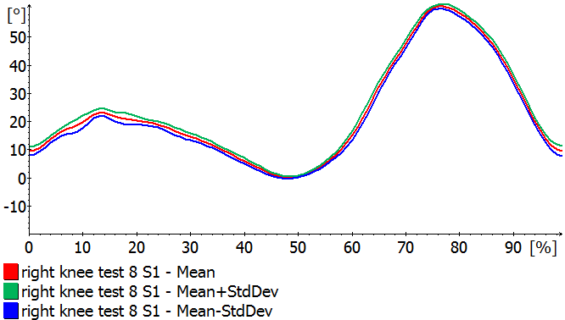
Fig. 1. A figure caption is written with 10 pts, centered and placed below the illustration at 6 pts and at 6 pts before the next text
For citations of references, the square brackets and consecutive numbers must be used. The following bibliography provides a sample reference list with entries for journal articles [1], a chapter [2], a book [3], proceedings without editors [4], and a URL [5].

- References
References are cited in the text just by square brackets [1]. Two or more references at a time may be put in one set of brackets [3, 4]. More consecutive references at a time may be put in one set of brackets [5-9]. The references are to be numbered in the order of appearance in the text.

References
- Author, C.: Article title. Journal, 24(3), pp. 15-20, 2019.
- Author1, C., Author2, S.: Paper title. In: Editor1, G., Editor2, B. (eds.) CARE 2020 Conference, vol. 1, pp. 131-142, Publisher House, Location, 2020.
- Author1, C., Author2, S., Author3, A.: Book title. 2nd edition, Publisher, Location, 2017.
- Author, S.: Contribution title. In: Proceedings of the 9th International Conference on Advanced Research, pp. 21-28, Publisher, Location, 2014.
- http://www.springer.com/conference, last accessed 2016/11/21.

